KATARINA CEHOVSKI

ASSIGNMENT A

**Request 1**

List the last name, first name and employee number of all programmers who were hired on or before 21 May 1991 sorted in ascending order of last name.

**Expected**

3 columns   
Last_Name, First_Name, Employee_No  
Cehovski, Katarina, 123  
…

**Query**

SELECT e.Last_Name, e.First_Name, e.Employee_No

FROM Employees e JOIN Jobs j ON j.Job_ID = e.Job_ID WHERE

j.Job_Title = 'Programmer' AND e.Hire_Date <= '1991-05-21' ORDER BY Last_Name ASC

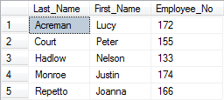

**Request 2**

List the department number, last name and salary of all employees who were hired between 16/09/87 and 12/05/96 sorted in ascending order of last name within department number.

**Expected**

3 columns   
Department_No, Last_Name , Annual_Salary  
120, Cehovski, 14000  
…

**Query**

SELECT Department_No, Last_Name, Annual_Salary FROM Employees WHERE

Hire_Date BETWEEN '1987-09-16' AND '1996-05-12' ORDER BY Department_No, Last_Name ASC

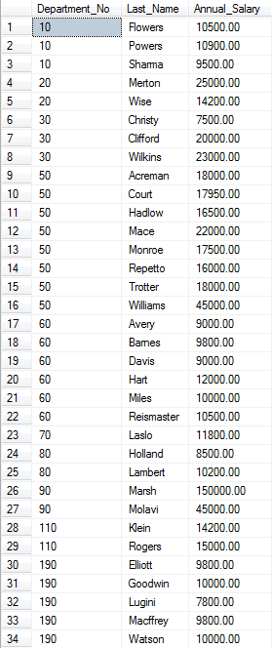

**Request 3**

List all the data for all jobs where the maximum salary is greater than 15000 sorted in descending order of the maximum salary.

**Expected**

4 columns  
Job_ID, Job_Title, Min_Salary, Max_Salary  
IT_SOF_DEV, Software Developer, 15000, 25000   
…

**Query**

SELECT * FROM Jobs WHERE Max_Salary> 15000 ORDER BY Max_Salary DESC

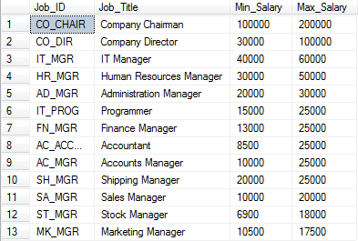

**Request 4**

List the last name, first name, job id and commission of employees who earn commission sorted in ascending order of first name within last name.

**Expected**

4 columns  
Last_Name, First_Name, Job_ID, Commission_Percent  
Cehovski, Katarina, IT_SOF_DEV, 0.15  
…

**Query**

SELECT Last_Name, First_Name, Job_ID, Commission_Percent FROM Employees WHERE

Commission_Percent IS NOT NULL ORDER BY Last_Name, First_Name ASC

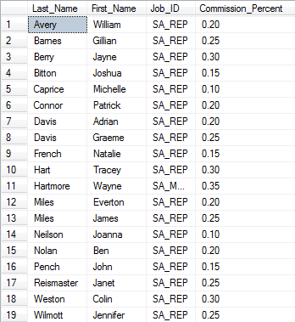

**Request 5**

Which jobs are found in the IT and Sales departments?

**Expected**

1 column   
Job_Title   
Programmer  
…

**Query**

SELECT DISTINCT Job_Title FROM Employees e

JOIN Jobs j ON e.Job_ID = j.Job_ID

JOIN Departments d ON d.Department_No = e.Department_No

WHERE Department_Name ='IT' OR Department_Name ='Sales'

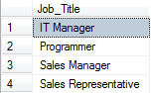

**Request 6**

List the last name of all employees in departments 50 and 90 together with their monthly salaries (rounded to 2 decimal places), sorted in ascending order of last name.

**Expected**

2 columns  
Last_Name, Montly_Salary  
Cehovski, 1400.43  
…

**Query**

SELECT Last_Name, CAST(ROUND(Annual_Salary/12, 2) AS DECIMAL(8,2)) AS Monthly_Salary FROM Employees WHERE

Department_No = 50 or Department_No=90 ORDER BY Last_Name ASC

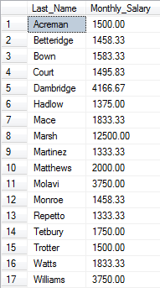

**Request 7**

Show the total salaries figure for one month displayed with no decimal places.

**Expected**

1 column with number  
Monthly_Salary  
10201

**Query**

SELECT CAST(SUM(Annual_Salary/12) AS INT) AS Monthly_Salary FROM Employees



**Request 8**

Show the total number of employees.

**Expected**

1 column with number  
Number_of_Employees  
64

**Query**

SELECT COUNT(Employee_No) AS Number_of_Employees FROM Employees



**Request 9**

List the department number, department name and the number of employees for each department that has more than 2 employees grouping by department number and department name.

**Expected**

3 columns   
Department_No, Department_Name, Number_of_Employees  
120, IT, 15  
…

**Query**

SELECT d.Department_No, d.Department_Name, COUNT(*) AS Number_of_Employees

FROM Departments d

JOIN Employees e ON d.Department_No = e.Department_No

GROUP BY d.Department_No, d.Department_Name

HAVING COUNT(*) > 2

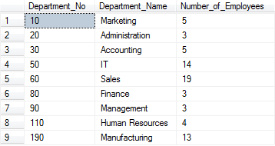

**Request 10**

List the department number, department name and the number of employees for the department that has the highest number of employees using appropriate grouping.

**Expected**

3 columns  
Department_No, Department_Name, Number_Employee  
150, Finance, 25

**Query**

SELECT TOP 1 WITH TIES d.Department_No, d.Department_Name,

COUNT(*) AS Number_Employee

FROM Departments d

JOIN Employees e ON d.Department_No = e.Department_No

GROUP BY d.Department_Name, d.Department_No

ORDER BY Number_Employee DESC



**Request 11**

List the department number and name for all departments where no programmers work.

**Expected**

2 columns  
Department_No, Department_Name  
50, Sales  
…

**Query**

SELECT d.Department_No, d.Department_Name

FROM Departments d

WHERE d.Department_No not in(

SELECT DISTINCT d.Department_No FROM Employees e

JOIN Jobs j ON e.Job_ID = j.Job_ID

JOIN Departments ON e.Department_No = d.Department_No

AND j.Job_Title= 'Programmer')

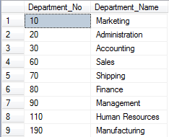

**Request 12**

Add the following new job IT_ANAL, System Analyst, 10000, 15000

**Expected**

New row will be added in table Jobs:  
Job_ID, Job_Title, Min_Salary, Max_Salary  
IT_ANAL, System Analyst, 10000, 15000

**Query**

INSERT INTO Jobs VALUES ('IT_ANAL', 'System Analyst', 10000, 15000)

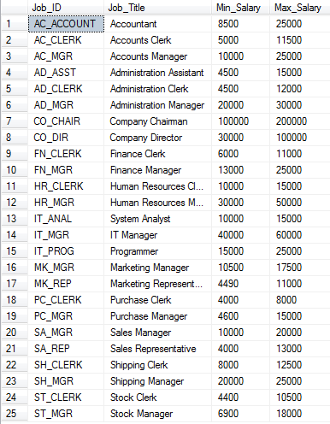

**Request 13**

Update all the maximum salaries for jobs with an increase of 1000.

**Expected**

4 columns  
column Max_Salary -> Before: 15000, After: 16000

**Query**

UPDATE Jobs SET Max_Salary += 1000

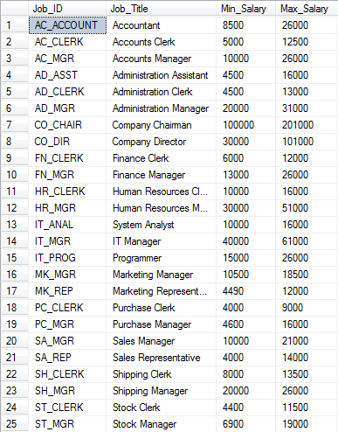

**Request 14**

List all the data for jobs sorted in ascending order of job id.

**Expected**

4 columns  
Job_ID, Job_Title, Min_Salary, Max_Salary  
AC_ACCOUNT, Accountant, 8500, 26000

**Query**

SELECT * FROM Jobs ORDER BY Job_ID ASC

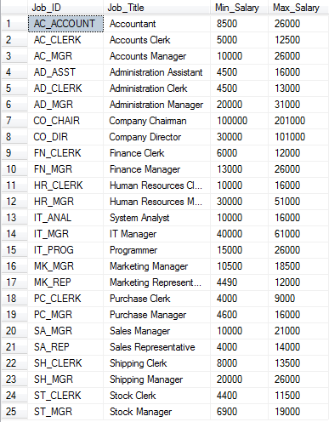

**Request 15**

1. The job history for employee number 102 is no longer required. Delete this record.

**Expected**

Employee with number 102 will no longer exist in table Job_History.

**Query**

DELETE FROM Job_History WHERE Employee_No= 102

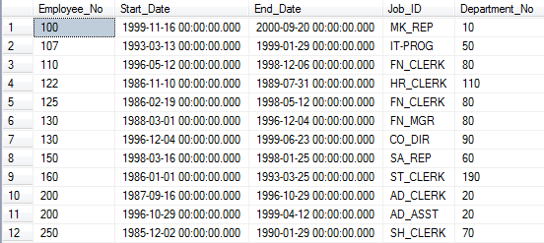

1. List all the data for job history sorted in ascending order of employee number.

**Expected**

5 columns  
Employee_No, Start_Date, End_Date, Job_ID, Department_No  
10, 12/05/1998, 20/08/2011, AD_ASST, 20

**Query**

SELECT * FROM Job_History ORDER BY Employee_No ASC

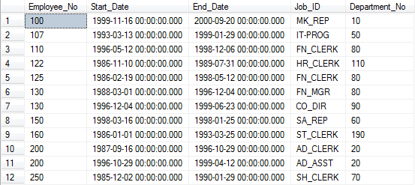

**Request 16**

Produce a list of employees showing percentage raises, employee numbers and old and new salaries. Employees in departments 20 and 10 are given a 5% rise, employees in departments 50, 80, 90 and 110 are given a 10% rise and employees in other departments are not given a rise.

**Expected**

4 columns  
Employee_No, Old_Salary, Raise, New_Salary  
123, 17000.00, 0.05, 17850.0000

**Query**

select e.Employee_No, e.Annual_Salary AS Old_Salary,

(

CASE

WHEN e.Department_No in (10,20) THEN 0.05

WHEN e.Department_No in (50,80,90,110) THEN 0.1

ELSE 0

END

) as Raise,

(e.Annual_Salary * (1+

(

CASE

WHEN e.Department_No in (10,20) THEN 0.05

WHEN e.Department_No in (50,80,90,110) THEN 0.1

ELSE 0

END

))) as New_Salary

from Employees e

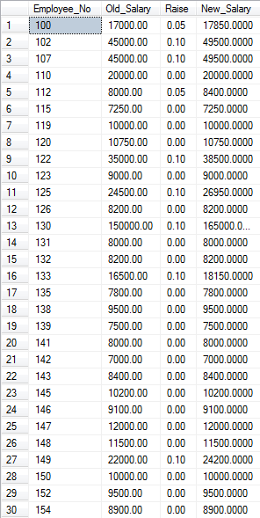

**Request 17**

Create a new view for manager’s details only using all the fields from the employee table. Apply a CHECK constraint.

**Expected**

New view table with 11 columns. Names of the columns will be the same like in table Employees, and it will contain details just for employees who are managers.

**Query**

CREATE VIEW Managers_Details AS

(

SELECT * FROM Employees

WHERE Job_ID LIKE '%MGR'

)

WITH CHECK OPTION

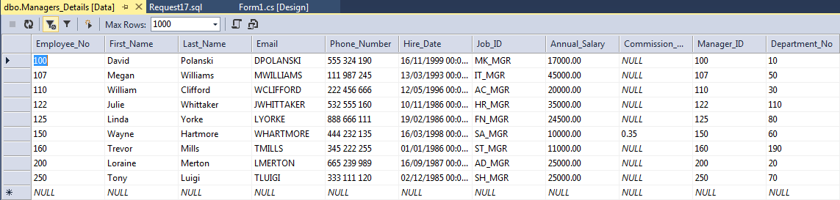

**Request 18**

Show all the fields and all the managers using the view for managers sorted in ascending order of employee number.

**Expected**

11 columns  
Employee_No, First_Name, Last_Name, Email, Phone_Number, Hire_Date, Annual_Salary, Manager_ID, Department_No  
123, Katarina, Cehovski, KCEHO, 452 542 546, 12/12/2012, IT_SOFT_DEV, 15000.00, 125, 50

**Query**

SELECT * FROM Managers_Details

ORDER BY Employee_No ASC

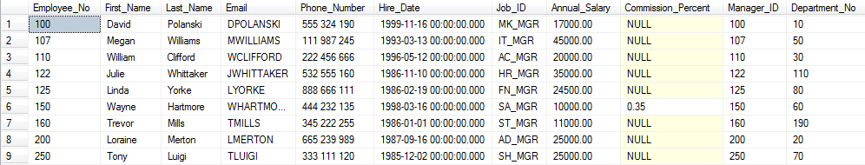

**Request 19**

Grant the authority to all other users to access the view for managers for SELECT statements only.

**Expected**

All users will be able to use only SELECT statement .

**Query**

GRANT SELECT ON Managers_Details TO PUBLIC



**Request 20**

Create an index named LOC_POSTAL_CODE on the Postal Code in the locations table. Provide a printout showing that the index has been created.

**Expected**

New index with name LOC_POSTAL_CODE will be added.

**Query**

CREATE INDEX LOC_POSTAL_CODE ON Locations (Postal_Code)

